WhatsApp Integration
Send Template Message using Engati
The template message feature allows sending personalized broadcast messages to all your active WhatsApp users. This is useful for sending announcements, promotions, alerts and more.
Step 1: Accessing the Create Account Page https://app.engati.com/admin/login.
Step 2: Filling in the Account Details.
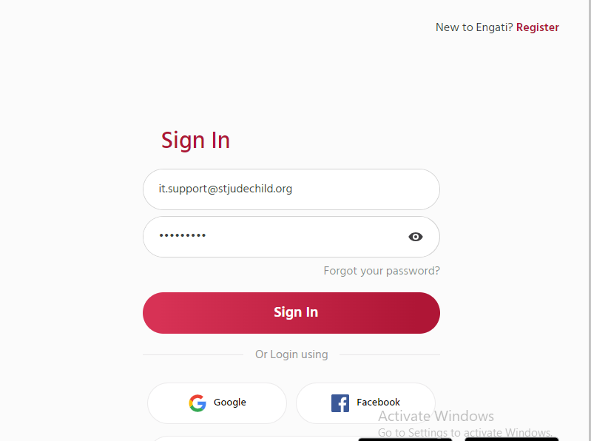
Step 3: In the engati portal navigate to Marketing Campagins > Message Templates, click on "..." button beside the template you want to sent and select Generate cURL.
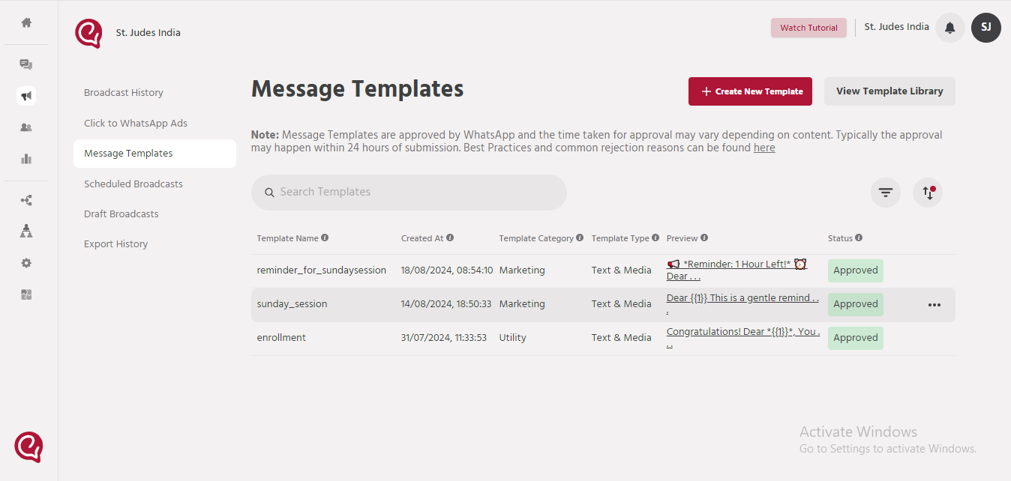
Step 4 : Copy the cURL generated.
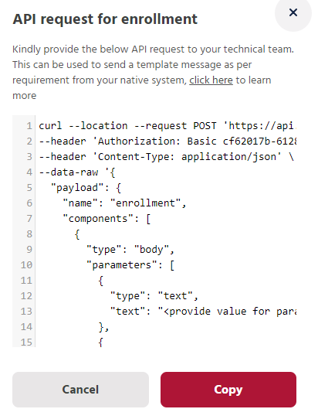

Step 5 : Import the copied cURL in postman and replace the variables with the values of the attributes in the Body section that were created during the template creation process.
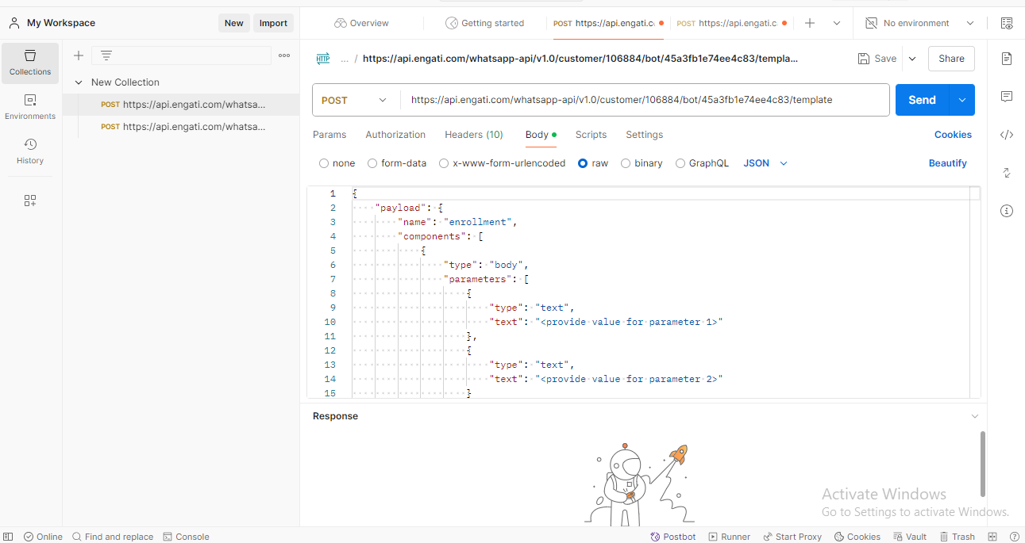
Step 6 : Once done adding text, images and receiver phone number in respective places, click on "Send" to send the template.
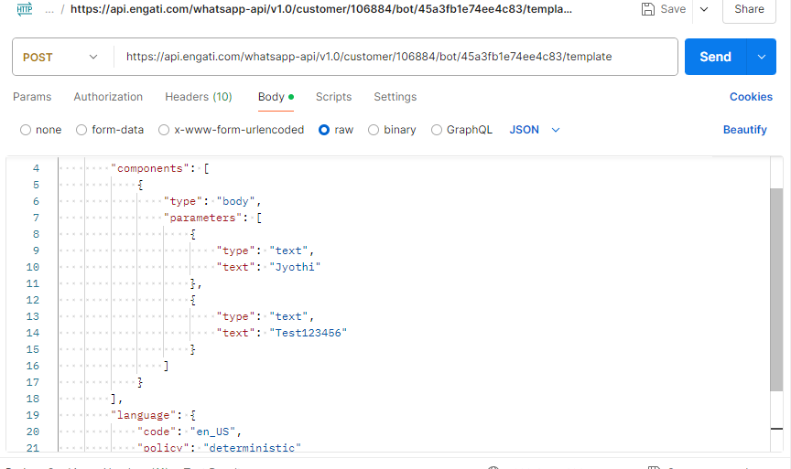
Responses
Step 7: Upon Clicking the Send Button, it will send the responses as Success, Failed to validate contact, Failed to send message, Bot not found, API Key Not Found & other Failures if any error occurs.
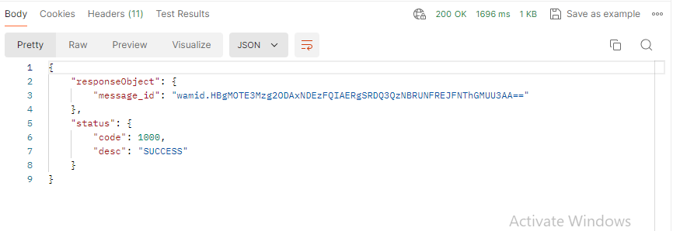
If the Response is Success, then the we will get the below Message.
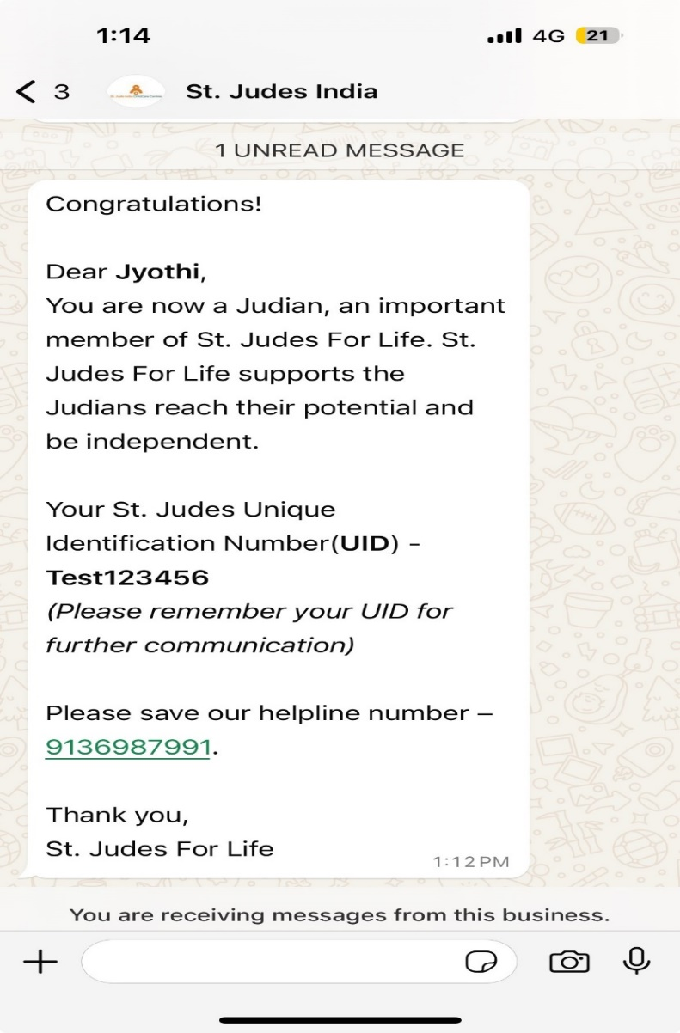
Step 8: Create Setup table
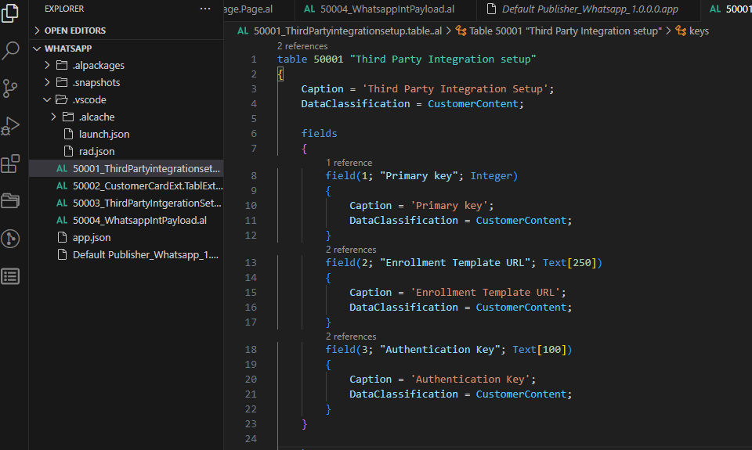
Step 9: Setup Page:
- 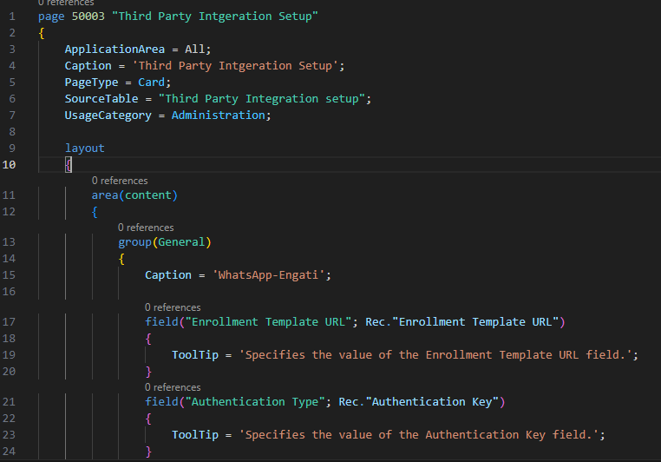
Step 10: Create a Code Unit.in that we need to add different procedures like
Setbody() [this creates JSON Body]
procedure SetBody(var Content: HttpContent) Result: Text
var
JsonObject: JsonObject;
JsonPayload: JsonObject;
JsonComponents: JsonArray;
JsonComponent: JsonObject;
JsonParameters: JsonArray;
FirstJsonParameter: JsonObject;
SecondJsonParameter: JsonObject;
JsonLanguage: JsonObject;
begin
// Create the payload object
JsonPayload.Add('name', 'enrollment');
JsonComponent.Add('type', 'body');

// Add the first text parameter
if GlobalName <> '' then begin
FirstJsonParameter.Add('type', 'text');
FirstJsonParameter.Add('text', GlobalName);
JsonParameters.Add(FirstJsonParameter);
end;

// Add the second text parameter
if GlobalUIDNo <> '' then begin
SecondJsonParameter.Add('type', 'text');
SecondJsonParameter.Add('text', GlobalUIDNo);
JsonParameters.Add(SecondJsonParameter);
end;

// Add parameters to the component
JsonComponent.Add('parameters', JsonParameters);
JsonComponents.Add(JsonComponent);

// Add components to the payload
JsonPayload.Add('components', JsonComponents);

// Add language object to the payload
JsonLanguage.Add('code', 'en_US');
JsonLanguage.Add('policy', 'deterministic');
JsonPayload.Add('language', JsonLanguage);

// Add namespace to the payload
JsonPayload.Add('namespace', '8b0d8a4b_642c_4bd2_9f8e_e7dedfea4110');

// Add payload to the main object
JsonObject.Add('payload', JsonPayload);

// Add phone number to the main object
JsonObject.Add('phoneNumber', GlobalReceiverPhoneNo);

// Return the JSON string
JsonObject.WriteTo(Result);

Content.WriteFrom(Result);
end;

SetHeaders()[Creates JSON Headers]
local procedure SetHeaders(var Content: HttpContent; var Request: HttpRequestMessage)
var
Headers: HttpHeaders;
AuthorizationValue: Text;
begin
Content.GetHeaders(Headers);
Headers.Clear();
Headers.Remove('Content-Type');
Headers.Add('Content-Type', 'application/json');
Request.GetHeaders(Headers);
end;

HttpMethods here in this integration we use POST Method.
local procedure Post(var Content: HttpContent; var Request: HttpRequestMessage; var ResponseText: Text)
var
Base64Convert: Codeunit "Base64 Convert";
Client: HttpClient;
ErrorText: label 'Something Wrong. Please retry.';
Response: HttpResponseMessage;
begin
Request.Content := Content;
Request.SetRequestUri(GlobalThirdPartyIntegration."Enrollment Template URL");
Request.Method := 'POST';

Client.DefaultRequestHeaders.Add('Authorization', 'Basic ' + GlobalThirdPartyIntegration."Authentication Key");

if Client.Send(Request, Response) then
Response.Content.ReadAs(ResponseText)
else
Error(ErrorText);
end;

ReadResponse()[use to read the Response].
procedure ReadResponse(jsonText: Text)
var
JsonToken: JsonToken;
JsonObject: JsonObject;
ResponseObject: JsonObject;
StatusObject: JsonObject;
MessageIDToken: JsonToken;
StatusCodeToken: JsonToken;
StatusDescToken: JsonToken;
MessageID: Text;
StatusCode: Integer;
StatusDesc: Text;
begin
// Parse the input JSON string into a JsonObject
if JsonObject.ReadFrom(jsonText) then begin
// Get the JsonToken for the "responseObject"
if JsonObject.SelectToken('responseObject', JsonToken) then begin
ResponseObject := JsonToken.AsObject();
ResponseObject.SelectToken('message_id', MessageIDToken);
MessageID := MessageIDToken.AsValue().AsText();
end;

// Get the JsonToken for the "status"
if JsonObject.SelectToken('status', JsonToken) then begin
StatusObject := JsonToken.AsObject();
StatusObject.SelectToken('code', StatusCodeToken);
StatusObject.SelectToken('desc', StatusDescToken);
StatusCode := StatusCodeToken.AsValue().AsInteger();
StatusDesc := StatusDescToken.AsValue().AsText();
end;

// Output the extracted values (You can modify this part as per your requirement)
Message('Message ID: %1\Status Code: %2\Status Description: %3', MessageID, StatusCode, StatusDesc);
end else
Error('Invalid JSON: Could not parse the input string.');
end;

procedure PostResponse(): Boolean
var
requestHeaders: HttpHeaders;
ResponseText: Text;
Request: HttpRequestMessage;
Client: HttpClient;
Content: HttpContent;
begin
GlobalThirdPartyIntegration.Get();
SetBody(Content);
SetHeaders(Content, Request);
Post(Content, Request, ResponseText);
ReadResponse(ResponseText);
end;

Step 11: Create Extension for Customer Card and add an action.
